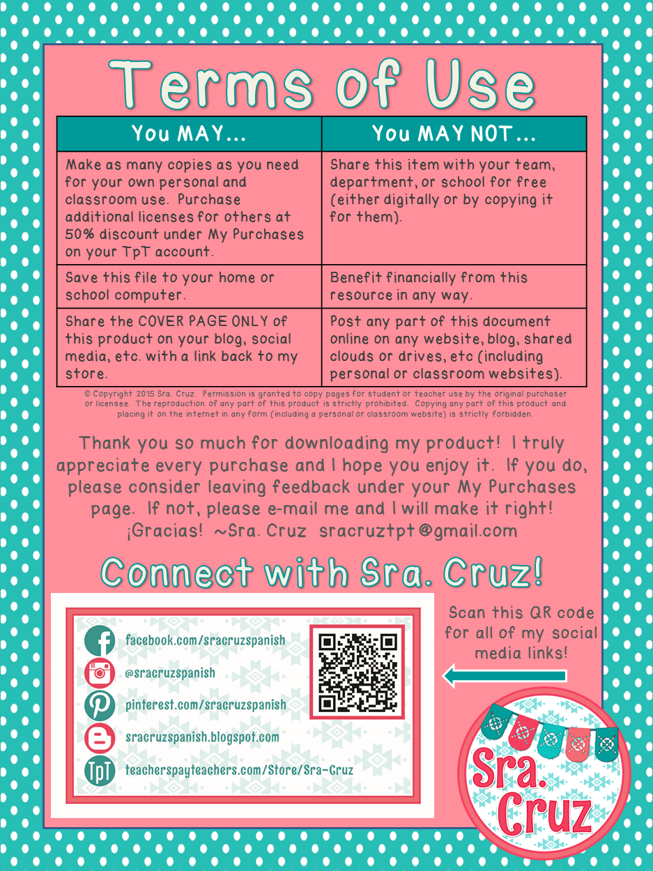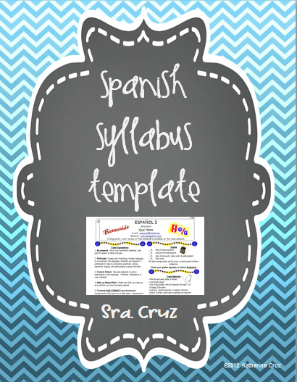

**©2012 Katherine Cruz**

**©2012 Katherine Cruz**

**Sra. Cruz**

ESPAÑOL I

2015-2016

Senora Shirey

E-mail: tshirey@tidioutecharter.com

Website: [tidioutecharter.com](http://sites.google.com/a/mail.fcboe.org/cruz/)

MCj01048320000%5b1%5d

MCj01048360000%5b1%5d

n

j0158007

**Class Expectations**

1. **Be prepared**: Have your homework, notebook, pen, pencil & paper in class everyday.

2. **Participate**: A large part of learning a foreign language is conversing in the language. Students are required to participate in class by answering questions, asking questions, singing, and participating in group activities.

3. **Come to School**: Success depends on active participation in the language. Therefore, attendance is very important.

4. **Make up Missed Work**: Make sure that you make up all work that you miss from being absent.

5. **Complete AND CORRECT your Homework**: Assignments will be given on a daily basis. Homework is checked in class and credit is given for completion. Students should do their homework and, most importantly, check it and correct any errors they have made. **Because we go over the answers to homework in class, late homework is not accepted.**

6. **Be Honest:** Cheating on any assignment will result in a zero. Cheating is considered using, giving or receiving unauthorized help. Also, students may not use software or the Internet to translate any material from English to Spanish for any assignment. This is considered plagiarizing and will result in a zero for the assignment and a referral to administration.

7. **Have Good Behavior:** Above all, students should be courteous and respectful to the teacher and each other. Students should never behave in a way that disrupts the class by preventing the teacher from teaching or the other students from learning. All behavior policies will be strictly enforced.

j0158007j0158007

**C:\Documents and Settings\cruz.katherine\Local Settings\Temporary Internet Files\Content.IE5\STNIV4S3\MC900088622[1].wmf**

**Grades**

25% tests & major projects

25% quizzes & small projects

25% daily (homework, class work, & participation)

25% tests

All other assignments will be given a value based on these categories.

**C:\Documents and Settings\cruz.katherine\Local Settings\Temporary Internet Files\Content.IE5\STNIV4S3\MC900359575[1].wmfCheck your grades regularly on Powerschool j0158007**

**Class Materials**

--Pencils and pens (blue or black)

--Loose-leaf paper

--notebook or 3 ring binder

--Folder

j0158007



It is extremely important that you keep all of your notes, vocabulary lists, and graded assignments organized in your notebook so that you can easily find them and use them to study.

j0158007

C:\Documents and Settings\cruz.katherine\Local Settings\Temporary Internet Files\Content.IE5\RDZDVQ8A\MC900150927[1].wmfj0158007**j0158007**

**Course Description**

The Level I language course focuses on the development of communicative competence in the target language and understanding of the culture(s) of the people who speak the language. The major means of communication between students and instructors will be in the target language. Through consistent and comprehensible exposure to grammatically-correct language, students develop an "ear" for language. By allowing students to proceed with natural language acquisition, fluency is promoted. Students no longer think about grammar rules–the main reason language production in traditional classes is typically low. The focus will be on the four areas of language: reading, writing, speaking and listening. Achievement will be measured in these areas by the use of performance-based assessments. These show us what the student can “do” using the language.

**Level I Units**

The Basics: Greetings, numbers, colors, etc.

All about Me: self, family, friends

School

House

Shopping and Clothing

Food

**How to Succeed in Spanish Class**

--Come to class.  
--Pay attention in class.  
--Study each day for at least 15 minutes outside of class.  
--Make flashcards (and study with them!) to help you learn vocabulary.  
--Ask someone to help quiz you on your vocabulary list.  
--Do your homework and correct it in class.  
--Check your grades regularly on Powerschool so that you always know where you stand.  
--Periodically review material from previous units. Spanish builds on itself so you will still need to know what we’ve already learned as the year progresses. It is not wise to “cram” material in before a quiz or test. The things that you did not learn will continue to haunt you throughout the year.   
**--Ask for help when you need it!**   
**--HAVE A GOOD ATTITUDE**

C:\Documents and Settings\cruz.katherine\Local Settings\Temporary Internet Files\Content.IE5\5C4PW6S3\MC900015880[1].wmfj0158007

Discipline Plan

* Respect yourself, your teacher, and your classmates.
* Follow all school rules and school board policies
* Follow my instructions the first time they are given
* Bring assigned materials to class
* No gum, candy, food, or drinks will be allowed in class.

# Consequences

1. Warning
2. Lunch Detention
3. Parent will be called and student will have detention
4. Administrative referral

j0158007**j0158007C:\Documents and Settings\cruz.katherine\Local Settings\Temporary Internet Files\Content.IE5\W3DD8Z9P\MC900089044[1].wmfC:\Documents and Settings\cruz.katherine\Local Settings\Temporary Internet Files\Content.IE5\5C4PW6S3\MC900437563[1].wmf**j0158007j0158007

Let’s Have a Great Year!



**Tardy Policy**

It is your responsibility to report to class on time. If you are tardy to class you will face the following consequences for:

1st = tardy is recorded.

2nd = tardy is recorded and parent is contacted.

3rd = tardy is recorded and student will serve a 30 minute lunch detention.

4th = administrative referral

**C:\Documents and Settings\cruz.katherine\Local Settings\Temporary Internet Files\Content.IE5\W3DD8Z9P\MC900434383[1].wmf**

**Cell Phone Policy**

Cell phones should not be used, seen, or heard in the classroom. They should be powered off and put away. If you think that you have accidentally left it on, please let me know and I will allow you to turn it off.

If your phone rings, makes a noise, or if you have your phone out without permission, I will take it from you.

Confiscated phones will be turned into the office and your parent or guardian must pick it up – no exceptions!